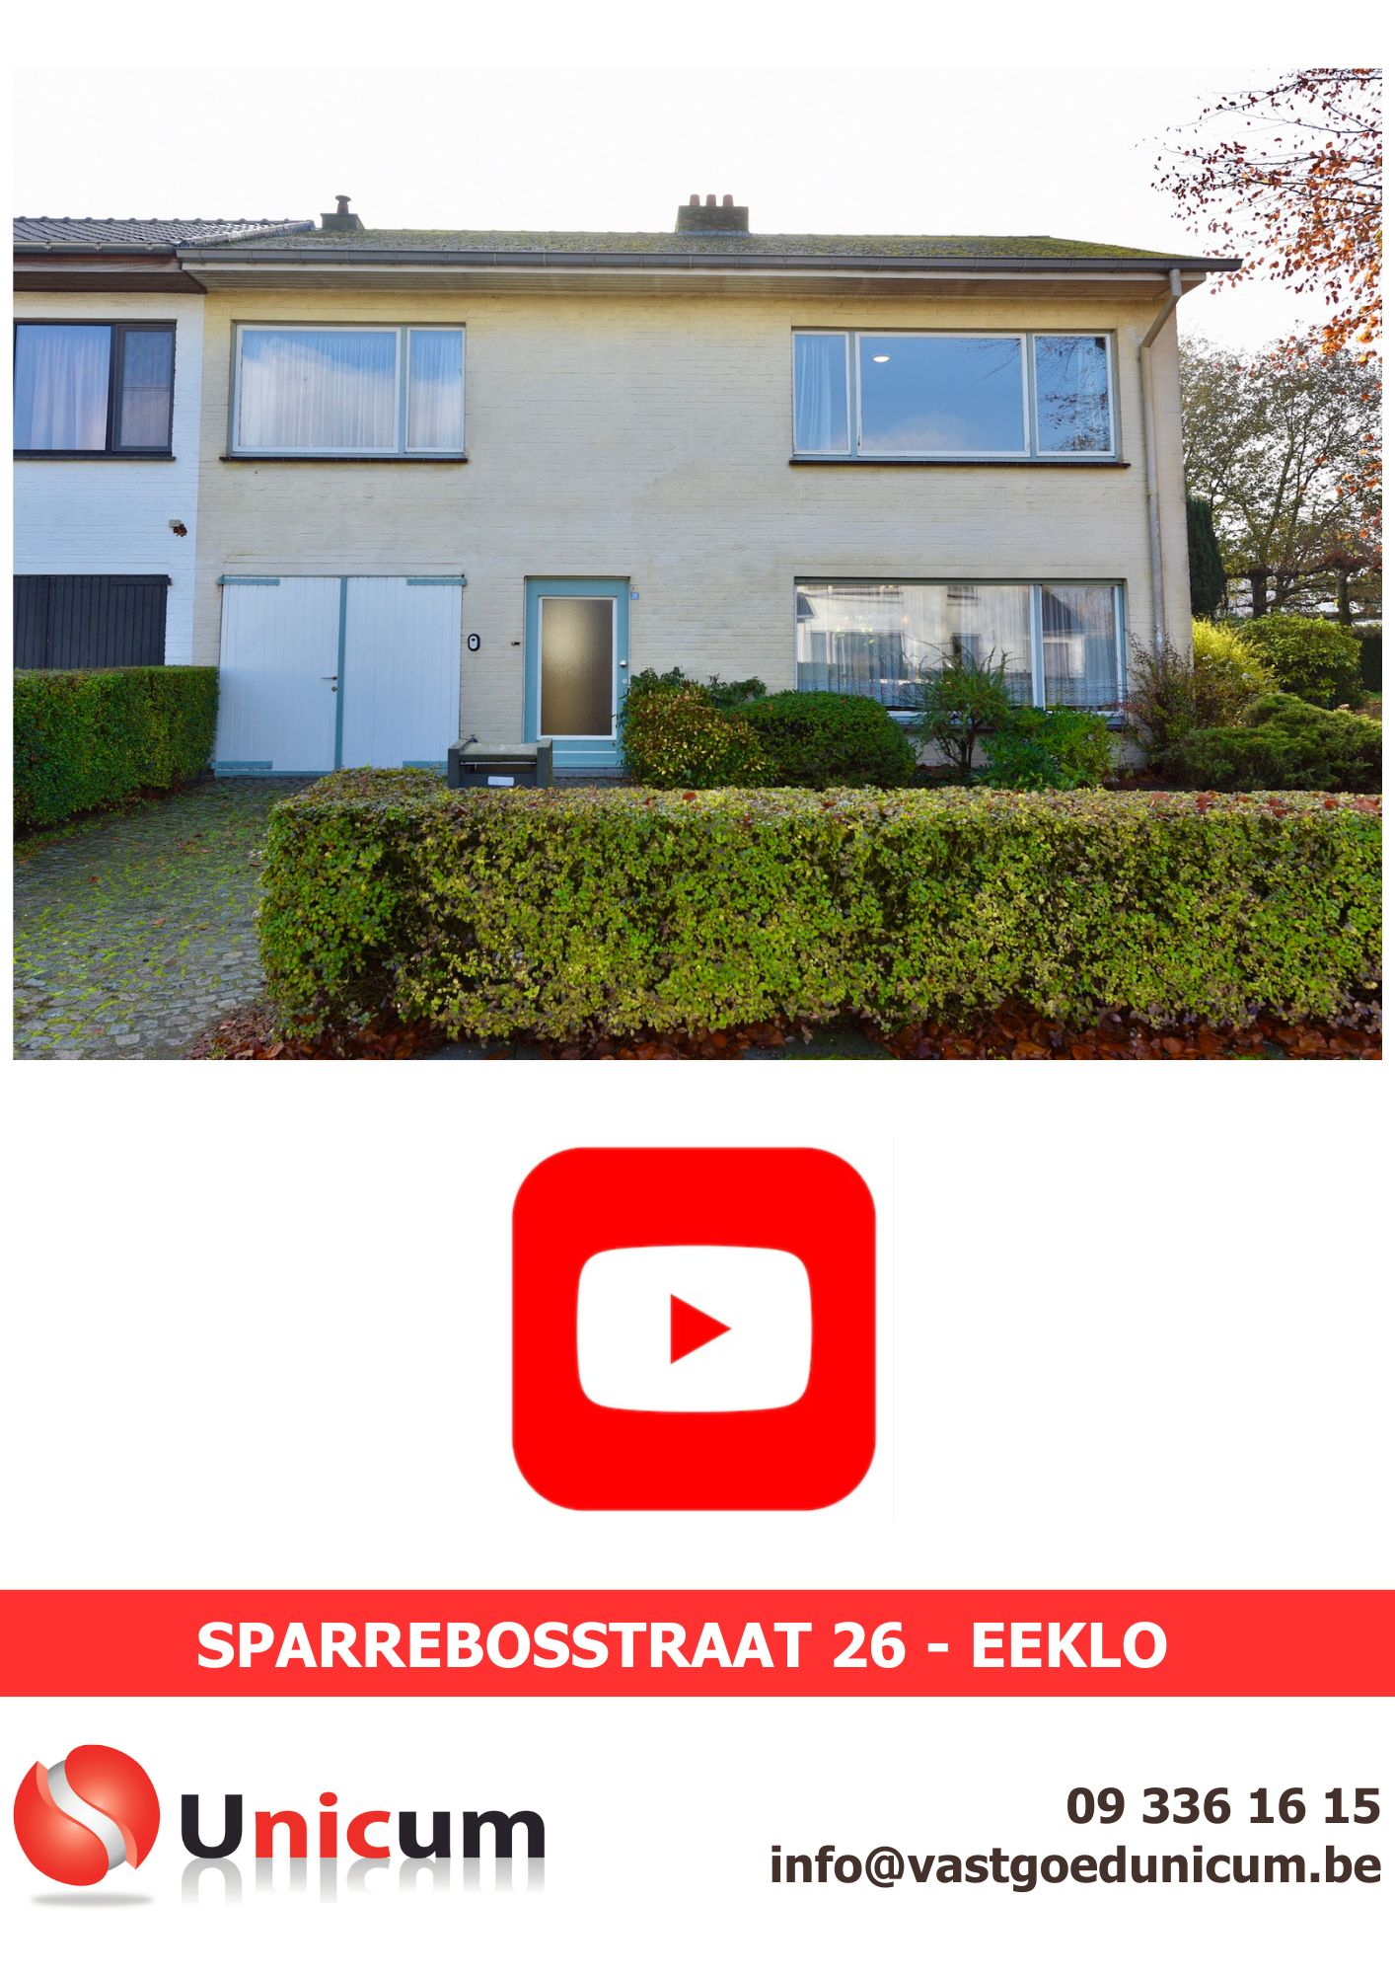

https://youtube.com/shorts/-QEB-6nrfCk

